MN State Standards:
Science:
3.1.3.4.1: Use tools, including rulers, thermometers, magnifiers and simple balance, to improve observations and keep a record of the observations made.
4.2.3.2.1: Identify several ways to generate heat energy.
5.3.4.1.1: Identify renewable and non-renewable energy and material resources that are found in Minnesota and describe how they are used.
5.1.1.2.3: Conduct or critique an experiment, noting when the experiment might not be fair because some of the things that might change the outcome are not kept the same, or that the experiment isn't repeated enough times to provide valid results.
ELA:
Collaboration:
3.8.1.1: Engage effectively in a range of collaborative discussions (one-on-one and groups and teacher-led with diverse partners on grade 3 topics and texts, building on others ideas and expressing their own clearly.
4.8.1.1: Engage effectively in a range of collaborative discussions (one-on-one and groups and teacher-led) with diverse partners on grade 4 topics and texts, building on others ideas and expressing their own clearly.
5.8.1.1: Engage effectively in a range of collaborative discussions (one-on-one and groups and teacher-led) with diverse partners on grade 5 topics and texts, building on others ideas and expressing their own clearly.
Presentation of Knowledge:
3.8.6.6: Speak in complete sentences when appropriate to task and situation in order to provide requested detail or clarification.
4.8.6.6: Differentiate between contacts that call for formal English (e.g. presenting ideas) and situations where informal discourse is appropriate (e.g. small group discussion); use formal English when appropriate task and situation.
5.8.6.6: Adapt speech to a variety of contacts and tasks using formal English when appropriate to task and situation

Overall Objectives: The students will be introduced to using Renewable Energy Resources as opposed to NONrenewable resources form Fossil Fuels and why it is better for the environment.
The students will be aware that there are renewable energy resources such as winder, water, and sun
The students will learn that cooking and heating homes can be powered using the sun
The students will build a Model Solar House
The students will make a solar own and cook s’mores
Most importantly, get the students excited about solar power with fun building activities and seeing the possibilities of this study in their future

Materials
Solar House
- 12 Solar House Kits containing walls, windows, and skylights and transparency film to cover windows
- Flooring materials: brick tiles, light tiles, and slate tiles
- 6 heat lamps
- 12 or 6 thermometers
- Timer
- Clear Tape
- Calculators
- Scissors
- Pencils
- Design a Solar House Packet
Solar Oven
- Link to video on how to create a solar oven: https://www.youtube.com/watch?v=kBmy-AeIzp0&t=40s
- 12 pizza boxes
- 24 clear sheet protectors
- 12 sheets of black construction paper
- Clear tape
- Blade
- 12 barbecue skewers
- 12 glue sticks
- 12 sheets of tin foil for flap and bottom
- Marshmallows
- Graham crackers
- Chocolate
- 12 thermometers
- Wet wipes

Academic Language:
- Solar power
- Nonrenewable energy
- Renewable energy
- Fossil fuels
- Solar panels
- Solar farms
- Solar oven
- Design process
- Thermometer
- Temperature
- Celscius
- Fahrenheit
- Experiment

Outline of Day 1-4
Essential Question: Will the use of windows and knowledge in solar power aid in the increase of internal temperature in a model house?
Will the use of windows and knowledge in solar power aid in keeping the temperature increased in a model house?
Day 1:
Content Objectives: Learn about renewable and nonrenewable energy sources.
Learn how nonrenewable energy such as Fossil Fuels are bad for the environment.
Learn about solar panels and farms in America.
Language Objectives: SWBAT discuss the differences between renewable and nonrenewable energy.
SWBAT write about observations and questions made about solar panels, solar farms, and solar power.

- Introduction and Greeting WE DO
  - Greeting: 1,2,3 Pop
  - Sharing: favorite part about summer so far
  - Game: Arm Hockey
- Watch videos about solar panels and solar farms YOU DO. As students watch the video, they will fill out their I Notice, I Wonder charts in their packet. Afterwards, have a quick discussion. ACCOMMODATION: Students can draw instead of write
- Read the book Solar Story: How One Community Lives Alongside the World’s Biggest Solar Plant I DO. I will either read the whole story or part of the story so students can see another solar plant in a different country.
- Have students look over and read different books about sun, solar energy, and renewable energy YOU DO TOGETHER. Students will do this with a partner of their choosing and continue to fill out the I Notice I Wonder chart.
Throughout the entire lesson, I asked prompting questions (What do you already know about solar energy? What do you know about solar panels and solar farms? What did you notice or wonder after watching the video?) All students will have the chance to share with the group. While the students are reading, walk around and listen to their conversations. Be a silent observer. ACCOMMODATION: You can read to the students who can’t read as well since they are younger.

Day 2:
Content Objective: Learn about the Solar House design process and requirements.
Language Objectives: SWBAT design the Solar House on paper working with a partner of their choosing following all requirements.
SWBAT use addition to solve how much each window and flooring is going to cost in our Solar House.

- Quiz on student names I DO. Students hearing their names is super important so try your best to remember them all and pronounce them correctly.
- Quick recap of what we did yesterday. WE DO. We discussed what we did yesterday and what we noticed and wondering about solar panels, solar farms, and solar power.
- Introduce Design a Solar House Project I DO. Pass out packets to students and go through each part of the design process. Make sure to explicitly model what sides are where and what the requirements are.
- Have students get in pairs (YOU DO) and begin drafting what they want their house to look like. YOU DO TOGETHER. In their groups, students will get the chance to decide what windows and flooring they want. Students have free range when it comes to this design process. Make sure to emphasize they need to decide together and make sure the price of their materials does not exceed $40,000. Have calculators to check their work but not to do the work themselves. ACCOMMODATION: Allow students less window options to work with if overwhelming and provide them the calculator right away.
- Complete drafting and turn in the plan to me YOU DO.
- If time, complete Solar Power word search. YOU DO TOGETHER OR YOU DO
As students are planning their houses, I check in with them to see how they are doing. Before any student can move on, we double check the math and make sure they met all the requirements. If majority of students finish this early in Day 2, begin the construction process.

Day 3:
Content Objective: Learn about the safety procedures and materials used in the Solar House construction.
Language Objective: SWBAT construct the Solar House with a partner following proper safety procedures.

- Recap of house plans and what expectations are. WE DO. Similar to Day 2, we discuss what we learned yesterday and how we designed our house.
- Go over safety procedures and materials. I DO OR WE DO. This part could be either or. You can have the safety procedures ready to tell them or you could create the list together as a class.
- Construct the house YOU DO TOGETHER. Students will have the majority of the time during Day 3, to build with their partner. When they are done, they can help another group.
- Discuss the difference between Celsius and Fahrenheit. I DO
- Potentially start experiment YOU DO TOGETHER
As students are building, I will circulate and see what assistance I can give them. The foam board isn’t the easiest to cut with so remind students their windows and skylights are not going to be perfect. Cutting through the foam board is tricky with scissors so plan for the entire day to be building and constructing the house. The cutting is the hardest part. There is a pocket knife in the blue bin that might be able to cut it better. ACCOMMODATION: Pre-cut/pre-score windows and skylights for students who have tactile sensitivities or cannot use scissors.

Day 4:
Content Objectives: Complete Solar House temperature experiment with a prediction.
Learn and observe how the sun can cook food.
Language Objectives: SWBAT test our Solar Houses to see how efficient they are.
SWBAT predict how much the temperature will increase during the experiment.
SWBAT observe and discuss how a solar oven cooks food leaning on prior knowledge.

- Set up for experiment and expectations. I DO. Prep all necessary materials ahead of time and make sure there is no confusion about any part of the lesson.
- Start experiment YOU DO TOGETHER. Students will bring out the necessary flooring they chose for their house along with something to move their house on. ACCOMMODATION: Choose to only measure temperature once instead of twice.
- Create smores for the finale WE DO. Make sure to tell the students that they have to share the solar ovens with others and that the s’mores might not get super gooey. Also write students' names on sticky notes where there s’more is in the oven in case there are dietary restrictions. ACCOMMODATION: Have students build and construct solar oven together as a group if there is extra time
Before beginning the experiment, make sure students predict how much their temperature is going to increase. Each group of students will bring outside (or use heat lamps if weather is not good) their finished Solar House, flooring of their choosing, packet and a thermometer. Go outside, find a sunny place and set the house on flooring with the thermometer inside. Set a timer for 20 minutes. After the 20 minutes is up, students will check the thermometer, record the temperature, and then carefully move their solar house out of the sun and let it sit for another 20 minutes.
During the 20 minutes of wait time, have students make s’mores in the solar oven. You can either prep the solar oven (link in materials) beforehand or have the students assist in creating it. Best to bake s’mores for about 15-20 minutes. ACCOMMODATION: Provide marshmallows that have beef gelatin in them for students who are Muslim or have other deitary needs.Provide a nonallergan alternative snack
During the downtime, have students complete the assessment questions at the back of their packet. Students can decide to take their houses home or we can keep them as examples for next time.

Assessment: Each day, I will collect and look at what the students wrote down in their packets. I will make informal notes about the students that need extra prompting and assistance as well as the students who seem to understand the concept. On the final day, there is a very informal summative assessment asking questions about what they enjoyed, what they would do differently and if they met the experiment goals.

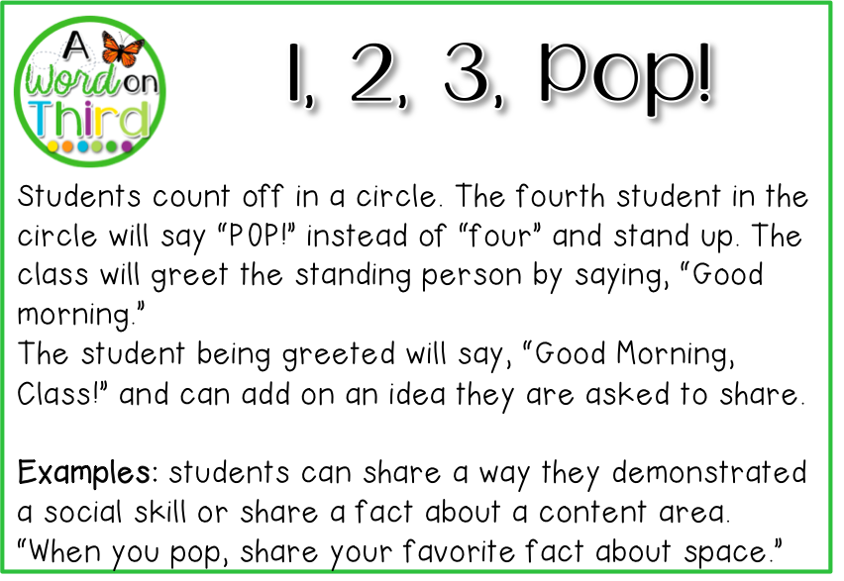
Backup activities:
- Trace our shadows with chalk YOU DO TOGETHER
- Electricity walk around the school WE DO
- Solar Power Word Search YOU DO OR YOU DO TOGETHER

Presentation link: Solar Power Presentation

Day 1: I Notice I Wonder

I Notice | I Wonder

Design a Solar House

You have been recruited by Green Homes, INC. to design a solar house! Your final goal is to create a solar house that uses renewable resources to heat the home. The requirements for your home are written below.

Requirement for your model Solar House
- At least 1 window on 2 different sides of the house
- At least 1 type of flooring
- A building cost of $40,000 or less
Cost of materials:
- Square Window $1,800
- Round Window $2,100
- Skylight $3,200
- Brick Flooring $6,000
- Tile Flooring $4,000
- Slate Tile Flooring $8,000

Below and on the next page, you will see plans for the four walls, and roof. This is your rough draft of where you want to place windows. Remember to add up the cost of each window and flooring!

Cost of Materials Chart
Item | Cost per Item | Quantity | Total Cost
Window: Square | $1,800
Window: Round | $2,100
Skylight | $3,200
Flooring: Brick | $6,000
Flooring: Light Tile | $4,000
Flooring: Slate | $8,000
Total Overall Cost

Show your work!

Solar Power Temperature Experiment

To test how effective your solar house is, we are going to run an experiment. Our goal is to have the temperature inside the house increase by at least 4 degrees above the starting temperature after heating for 20 minutes. After the heat source is taken away for 20 minutes, the temperature inside the house should be at least 1 degree above starting temperature.

Experiment Directions:
- Before we begin, make a prediction for how much your solar house temperature will increase.
- Bring your completed Solar House with flooring outside or near the heat lamp.
- Record beginning temperature and put the thermometer inside the house.
- Let the house sit for 20 minutes.
- Record temperature after heating.
- Bring Solar House in shade and remove the heat lamp and let it sit for 20 minutes.
- Record final temperature.

Predictions: My solar house will increase temperature by _____________ degrees after heating for 20 minutes.

Solar House Temperature Chart
Beginning Temperature
Temperature After Heating
Final Temperature

After Experiment Questions:
- How much did the temperature change between the Beginning Temperature and Temperature After Heating?

- How much did the temperature change between the Temperature After Heating and Final Temperature?

- Was your prediction correct? If not, why do you think it wasn’t?

- Was your Solar House able to meet the 2 temperature goals? How?

- Look at other groups' solar houses. What changes would you make if you had to do this again and why?

- What was your favorite part about STEM Camp?

