I’m ready for Kindergarten!
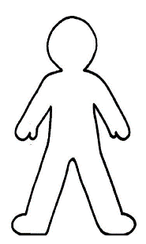
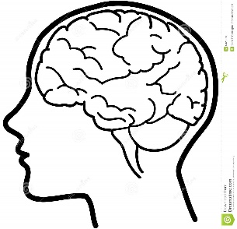

My Body is Ready! | My Brain is Ready! | My Heart is Ready!
- My immunization are complete.  - I use writing/drawing tools and scissors with control.  - I can copy figures and shapes.  - I can hop.  - I can jump.  - I can run. | - I can count up to 10.  - I can count groups of objects to 10.  - I can identify shapes like triangles, circles, and squares.  - I can sort and group objects by size, shape, and color.  - I can name my colors like red, orange, yellow, green, blue, purples, black, and white.  - I can recognize my name in print.  - I can write the letters in my first name.  - I can identify the letters.  - I can say the sounds of the letters.  - I can use letters or drawings to express my ideas on paper.  - I can retell stories.  - I can repeat familiar songs or rhymes.  - I can describe objects with a variety of words. | - I know my first and last names.  - I know my age.  - I can take care of my toiletry needs.  - I can separate from my parents.  - I can pay attention for about 10 minutes.  - I can share my space and my materials with others.  - I can take turns.  - I can follow two-step directions.  - I can solve a problem.  - I enjoy learning new things.  - I can express my ideas, feelings, and needs.

